SPH3U0 **Standing Waves** Name:_____________________

***Instructions: Read pages 313-314 and complete the following questions.***

Standing waves are produced when two waves with ______________ wavelengths and ___________

move through each other.

When crests from two waves or troughs from two waves occupy the same point in the medium, the waves are said to be _________________. These waves produce ______________________ interference.

When a crest from one wave occupies the same point in the medium as a trough from a second wave, we say that the waves are _______________________. These waves produce _________________

interference.

As the two waves pass through each other, they continually shift in and out of ____________ producing a wave that seems to ______________ between fixed points.

An image of a standing wave produced in Picture of various standing wave patterns

a vibrating string: produced at different vibration frequencies:

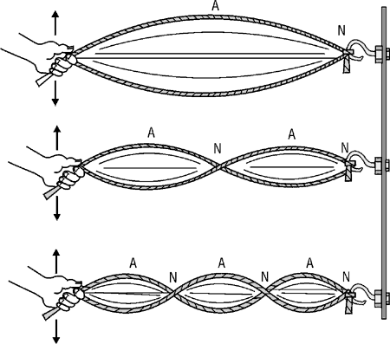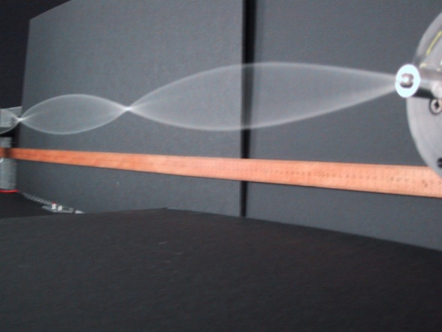

**Nodes and Anti-Nodes:**

At certain points, destructive interference will always occur. (See point A in figure 9.38). What are these points called? __________________________________

What is the spacing of these points? ____________________

In between these points, the waves switch between constructive and destructive interference. The midpoints of these regions are called ____________________.

Sketch a standing wave as shown in figure 9.40. Label the nodes, anti-nodes and the spacing between nodes

**Analyzing Standing Waves**

**Sample Question**: Two physics students playing with a long spring, produced a 4 loop standing wave by vibrating the ends at the same frequency and amplitude. They determined that the nodes in their wave were spaced 32.0 cm apart. If they were vibrating the spring at a frequency of 2.0 Hz, find:

a) the wavelength of the waves b) the speed of the waves.

1) A 16.0 m long string vibrates in a standing wave pattern such that 6 loops are produced.

a) Sketch the standing wave.

b) What is the wavelength of the wave?

c) If the frequency of vibration is 2.50 Hz, calculate the wave speed.

2) A standing wave is produced in a string by two waves travelling in opposite directions at a speed of 5.40 m/s. The distance between the third and seventh node is 12.0 cm. Find the wavelength and frequency of the waves.

Answers: 1) a) 5.33 m b) 13.3 m/s 2) λ = 0.600 m f = 9.00 Hz